**Final Project Report**

Student Name: Kim Sujin

Student ID: 2017310435

**1. Briefly describe the project purpose:**

The knowledge can be developed through various categorized quizzes.

**2. Draw the logic flow of the program (with flowchart):**

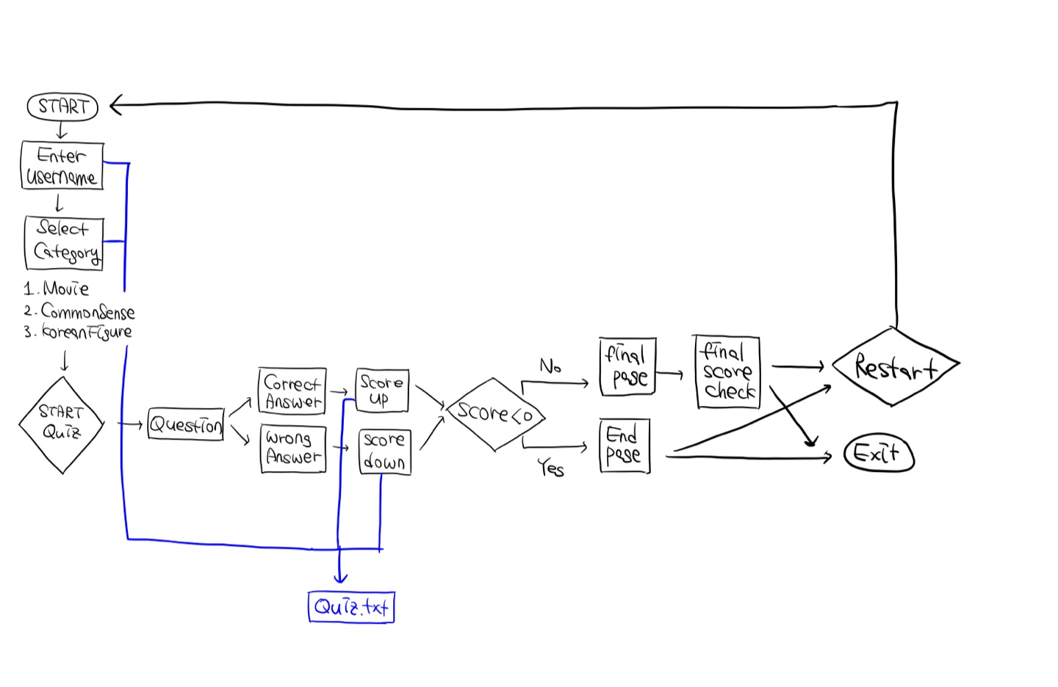

1. If the user enters a username, the username is written on the text file.

2. There are Movie, Commonsense, and Korean figure categories. If the user selects a catecory, it is also written on the text file.

3. If username or category isn't entered, error message window will show up.

4. The question shows up.

5. The user chooses the answer.

6. If the answer is correct, the score goes up(+10), and If the answer is wrong, the score godes down(-10). At the same time, the score is written on the text file. If the user's totol score is below 0, then the game is finished.

7. After solving 10 questions, the final result comes out. It is also written into the text file at the same time.

8. The user can finish the quiz or resart it.

**3. Provide screenshots for each screen with brief description:**

1. Start page : When Main.java is executed, the start page appears. The user can enter the username, choose category and start quiz. Also, user's information is written into text file at the same time.

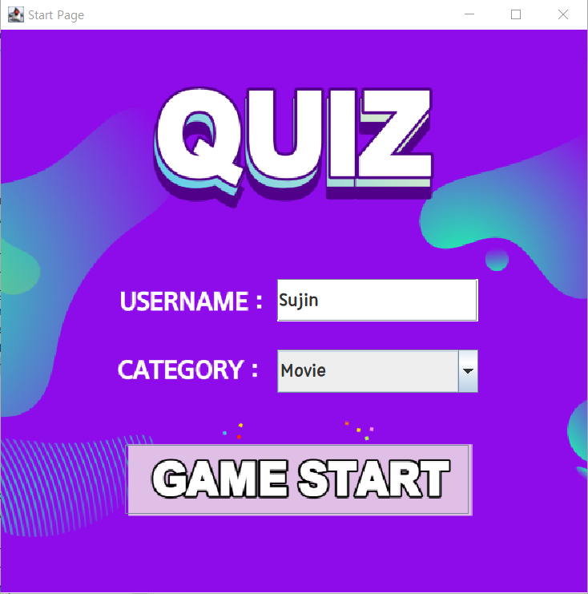 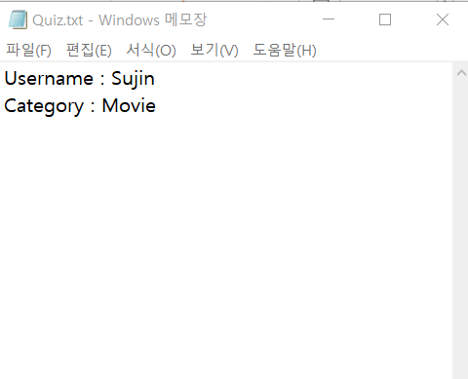

If I don't enter my username or select a category, the error message will show up.

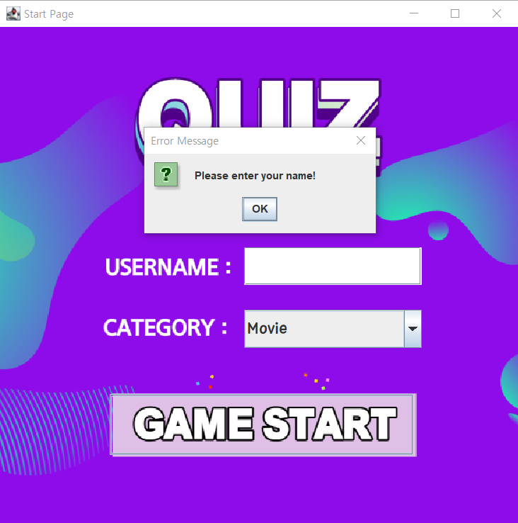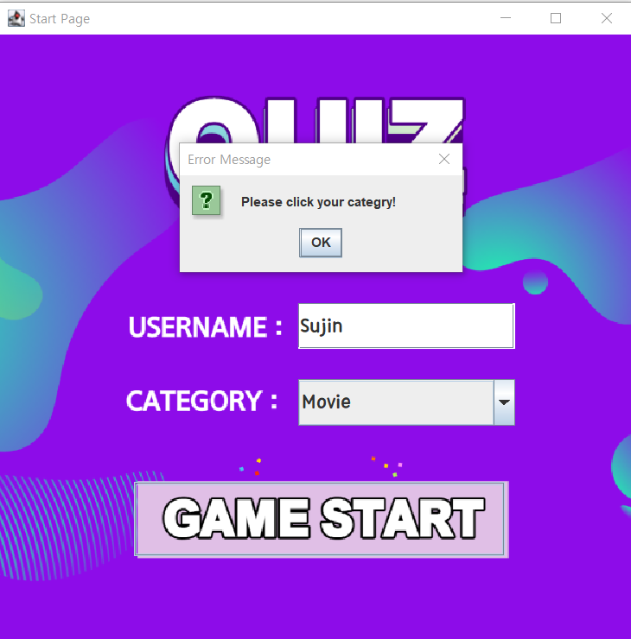

2. Game ON page : Question and views show up. If the user select correct answer, the total score increase by 10.

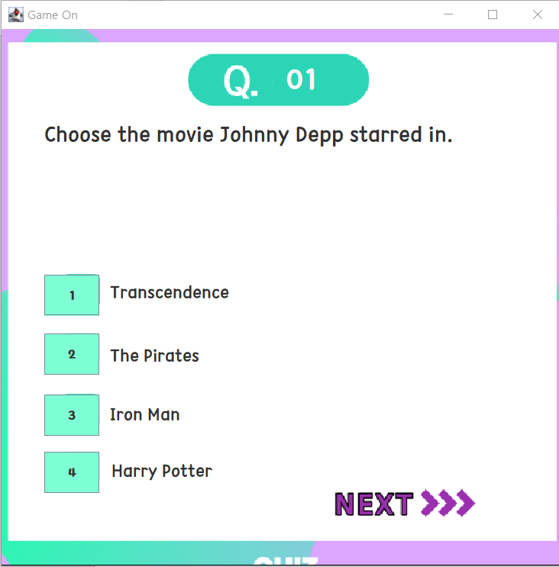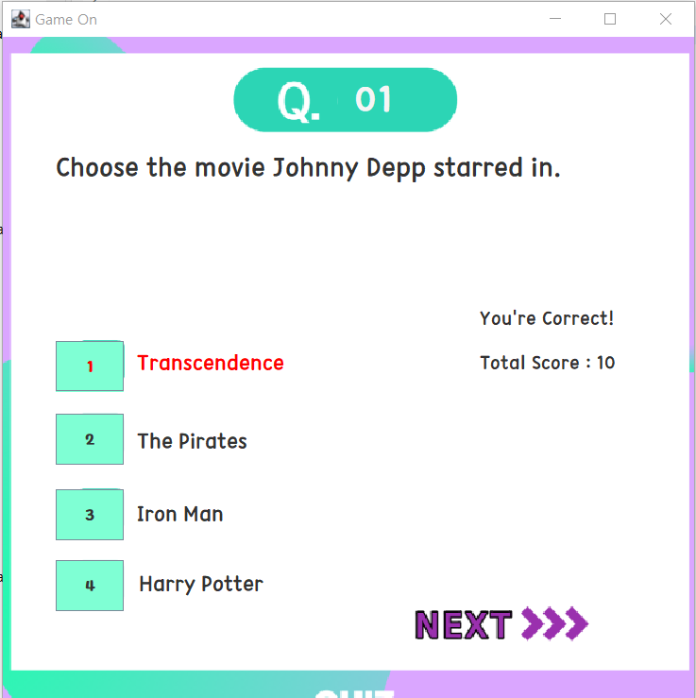

If the user selects the wrong answer, the total score decreases by 10.

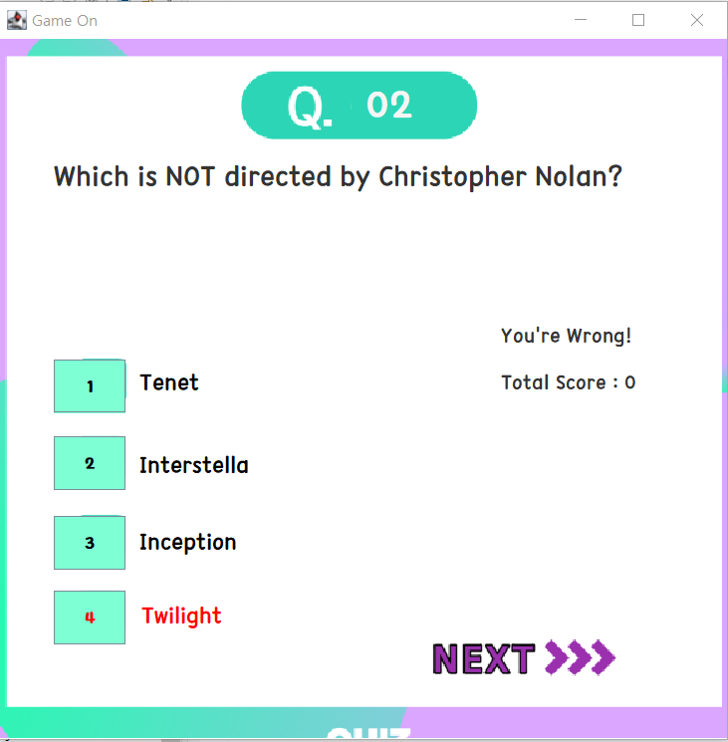

3. The result is written into the text file.

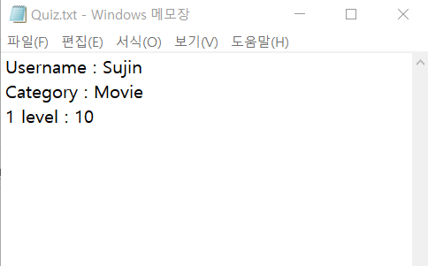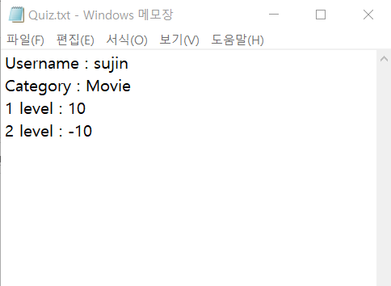

4. Final page : The user can check the score for each level and for sum. Also, the user can go to start page to restart the game or exit to finish the game.

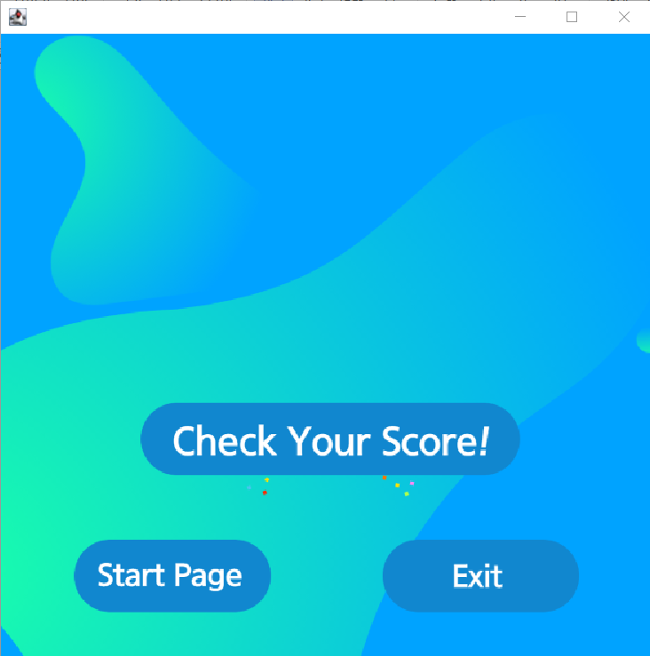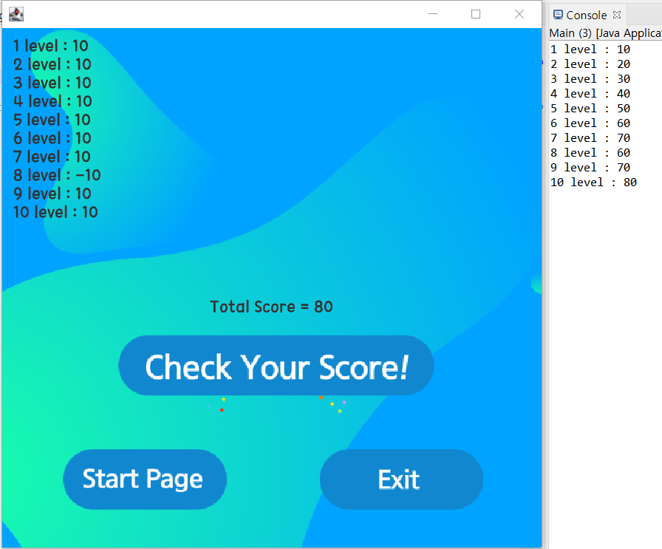

Click

Same

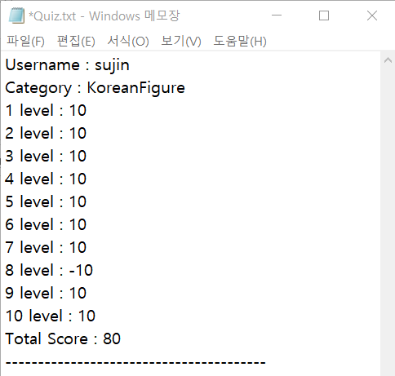

5. End Page : The score of user is below 0, the game is finished. Like Final page, The user can go to start page or exit.

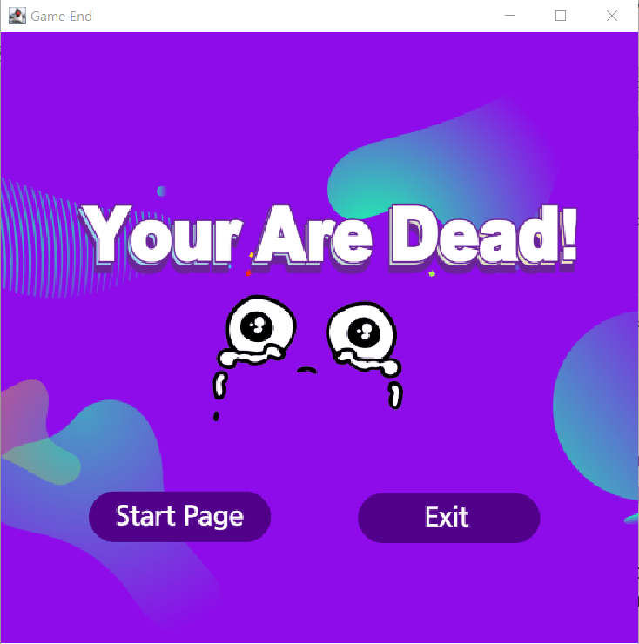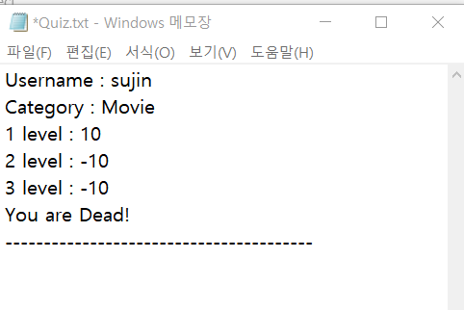

**4. Explain the code of the main functionalities**

1. The funcionality to insert an image to Panel

// Create the Jframe

frmStartpage = **new** JFrame();

frmStartpage.setTitle("Start Page");

frmStartpage.setBounds(100, 100, 450, 300);

frmStartpage.setDefaultCloseOperation(JFrame.***EXIT_ON_CLOSE***);

//Insert an image to Panel

ImagePanel startPanel = **new** ImagePanel(**new** ImageIcon(".\\Start.png").getImage());

// Fit the frame size into the size of an image

frmStartpage.setSize(startPanel.getDim());

rmStartpage.setPreferredSize(startPanel.getDim());

frmStartpage.getContentPane().add(startPanel);

frmStartpage.pack();

2. The functionality to extract questions from text files that I made previously.

// Extracting questions from txt files

String setQuiz(**int** num) {

String text = "";

ArrayList<Character> a = **new** ArrayList<>();

Character[] array;

**int** g = UserInfo.*genre*;

**try** {

// text file format : quiz_0_1.txt

FileReader fr = **new** FileReader("quiz_" + g + "_" + num + ".txt");

**int** ch;

**while** ((ch = fr.read()) != -1) {

a.add((**char**) (ch));

}

} **catch** (Exception e) {

e.getStackTrace();

}

array = a.toArray(**new** Character[a.size()]);

**for** (**int** i = 0; i < a.size(); i++) {

text = text + array[i];

}

**return** text;

}

3. The functionaility that gets the views from the answer database and sets it.

// The function that sets the next level views to the text field

**void** SetExample() {

**if** (UserInfo.*genre*==0) {

// Movie Catecory

FirstAnswer.setText(Answer_Database.*Movie_Database*[UserInfo.*current_level*][0]);

SecondAnswer.setText(Answer_Database.*Movie_Database*[UserInfo.*current_level*][1]);

ThirdAnswer.setText(Answer_Database.*Movie_Database*[UserInfo.*current_level*][2]);

FourthAnswer.setText(Answer_Database.*Movie_Database*[UserInfo.*current_level*][3]);

}

**else** **if**(UserInfo.*genre*==2) {

// CommonSense Catecory

FirstAnswer.setText(Answer_Database.*CommonSense_Database*[UserInfo.*current_level*][0]);

SecondAnswer.setText(Answer_Database.*CommonSense_Database*[UserInfo.*current_level*][1]);

ThirdAnswer.setText(Answer_Database.*CommonSense_Database*[UserInfo.*current_level*][2]);

FourthAnswer.setText(Answer_Database.*CommonSense_Database*[UserInfo.*current_level*][3]);

}

**else** {

// Korean Figure Catecory

FirstAnswer.setText(Answer_Database.*Figure_Database*[UserInfo.*current_level*][0]);

SecondAnswer.setText(Answer_Database.*Figure_Database*[UserInfo.*current_level*][1]);

ThirdAnswer.setText(Answer_Database.*Figure_Database*[UserInfo.*current_level*][2]);

FourthAnswer.setText(Answer_Database.*Figure_Database*[UserInfo.*current_level*][3]);

}

4. The functionality to extract the answer from answer database.

// 'ans' is the answer of question

**int** ans = 0;

// the 5th integer in each row is the answer of question

**if** (UserInfo.*genre*==0)

ans=Integer.*parseInt*(Answer_Database.*Movie_Database*[UserInfo.*current_level*][4]);

**else** **if** (UserInfo.*genre*==2)

ans=Integer.*parseInt*(Answer_Database.*CommonSense_Database*[UserInfo.*current_level*][4]);

**else** **if** (UserInfo.*genre*==3)

ans=Integer.*parseInt*(Answer_Database.*Figure_Database*[UserInfo.*current_level*][4]);

**5. Explain what is included in your project and why it is used (Polymorphism, Inheritance, File I/O, etc)**

· Polymorphism is included because I used 'actionPerformed(ActionEvent e)' interface method of ActionListener. I override this method to find out which button the user select.

· The Page Moving methods(go to Startpage or Finalpage or Endpage) is used frequently, so I collect the page moving methods in one class. Each Page inherits page moving methods.

· In real time, the user name and grading results will be recorded in the file, so file I/O and multi-thread are required.